Date
Team ID
Project Name | Optimizing User, Group, and Role Management with Access Control and  Workflows
Maximum Marks

Empathy Map Canvas:
An Empathy Map Canvas is a collaborative tool used to build a deep, shared understanding of your users, their needs, and their pain points. For a project focused on access control and workflow automation, it maps the specific perspectives of the system's users—such as employees, system administrators, or external approvers.

Empathy Map

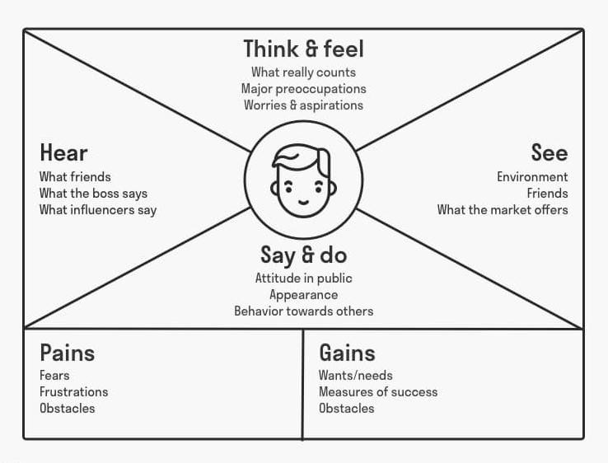

Example: Optimizing User, Group, and Role Management with Access Control and Workflows

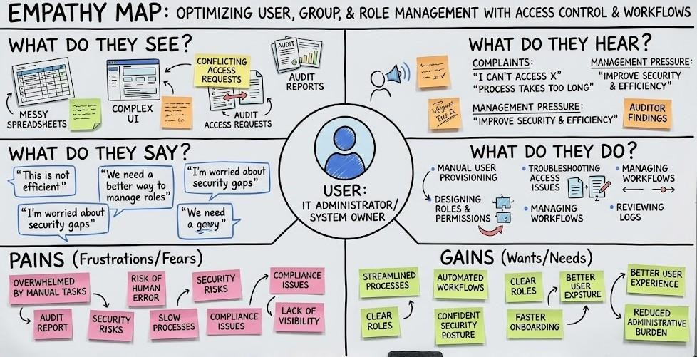

From a user’s perspective, the main need is simplicity and speed—being able to request access or role changes without confusion. They often feel frustrated when approvals take too long or when they are unsure about the status of their request. Group managers and administrators, on the other hand, need clarity, automation, and proper workflow tracking to reduce manual effort and avoid errors. They want a system that minimizes repetitive tasks, enforces security policies automatically, and provides transparency in access assignments.
This project focuses on improving the overall experience by optimizing user, group, and role management through structured access control and automated workflows. The goal is to balance security with usability, ensuring users get timely access while administrators maintain full control and visibility over the system.

